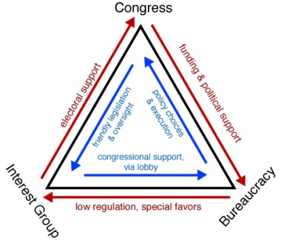

The Iron Triangle

Iron triangles
The closed, mutually supportive relationships that often prevail in the United States between the government agencies, the special interest lobbying organizations, and the legislative committees or subcommittees with jurisdiction over a particular functional area of government policy. As long as they hang together, the members of these small groups of movers and shakers tend to dominate all policy-making in their respective specialized areas of concern, and they tend to present a united front against "outsiders" who attempt to invade their turf and alter established policies that have been worked out by years of private negotiations among the "insiders." The middle-level bureaucrats who run the agencies may use their special friends in Congress to block the efforts of a new President or a new Congressional majority leadership bent on reforming or reducing the size of their agencies. The Congressmen and Senators on the oversight committees can count upon their friends in the agencies to continue "pet" programs and pork-barrel projects important to their local constituencies or even to do special favors for their political supporters and financial backers. Lobbying organizations provide useful information to the committees and the agencies, provide campaign support for the relevant Congressmen, and often help to mobilize public opinion in favor of larger appropriations and expanded programs for "their" part of the government bureaucracy. In return, they tend to be consulted and carefully placated when new laws or administrative regulations or important appointments affecting their special interests are being made. These triangles are said to be "strong as iron" in that these mutually supportive relationships are often so politically powerful that representatives of the more general interests of society are usually effectively prevented from "interfering" with policy-making altogether whenever their concept of the general interest runs counter to the special interests of the entrenched interest groups, bureaucrats and politicians.

